Assignment-2

**Canny edge detector algorithm**

Summer 2022 CS 59000 VT- Topic Computer Sci-XB9 Cross list

**By- Rudraksh Sugandhi**

**Code:**

1. **Include code with comments in the report.**

from scipy import misc

from scipy import ndimage

import numpy as np

import matplotlib.pyplot as plt

import imageio

import warnings

warnings.filterwarnings('ignore')

# Load image into variable and display it

lion = imageio.imread("Andrew.jpeg")

plt.imshow(lion, cmap = plt.get_cmap('gray'))

plt.show()

# Convert color image to grayscale to help

lion_gray = np.dot(lion[...,:3], [0.299, 0.587, 0.114])

plt.imshow(lion_gray, cmap = plt.get_cmap('gray'))

plt.show()

# Blur the grayscale image

lion_gray_blurred = ndimage.gaussian_filter(lion_gray, sigma=1.4)

plt.imshow(lion_gray_blurred, cmap = plt.get_cmap('gray'))

plt.show()

# Apply Sobel Filter using the convolution operation

def SobelFilter(img, direction):

if(direction == 'x'):

Gx = np.array([[-1,0,+1], [-2,0,+2], [-1,0,+1]])

Res = ndimage.convolve(img, Gx)

if(direction == 'y'):

Gy = np.array([[-1,-2,-1], [0,0,0], [+1,+2,+1]])

Res = ndimage.convolve(img, Gy)

return Res

# Normalize the pixel array, so that values are <= 1

def Normalize(img):

img = img/np.max(img)

return img

# Apply Sobel Filter in X direction

gx = SobelFilter(lion_gray_blurred, 'x')

gx = Normalize(gx)

plt.imshow(gx, cmap = plt.get_cmap('gray'))

plt.show()

# Apply Sobel Filter in Y direction

gy = SobelFilter(lion_gray_blurred, 'y')

gy = Normalize(gy)

plt.imshow(gy, cmap = plt.get_cmap('gray'))

plt.show()

# Apply the Sobel Filter using the inbuilt function of scipy, this was done to verify the values obtained from above

dx = ndimage.sobel(lion_gray_blurred, axis=1) # horizontal derivative

dy = ndimage.sobel(lion_gray_blurred, axis=0) # vertical derivative

# Plot the derivative filter values obtained using the inbuilt function

plt.subplot(121)

plt.imshow(dx, cmap = plt.get_cmap('gray'))

plt.subplot(122)

plt.imshow(dy, cmap = plt.get_cmap('gray'))

plt.show()

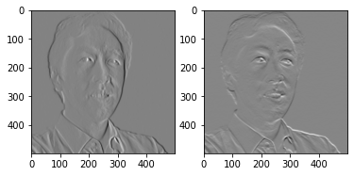

Gradient

# Calculate the magnitude of the gradients obtained

Mag = np.hypot(gx,gy)

Mag = Normalize(Mag)

plt.imshow(Mag, cmap = plt.get_cmap('gray'))

plt.show()

# Calculate the magnitude of the gradients obtained using the inbuilt function, again done to verify the correctness of the above value

mag = np.hypot(dx,dy)

mag = Normalize(mag)

plt.imshow(mag, cmap = plt.get_cmap('gray'))

plt.show()

# Calculate direction of the gradients

Gradient = np.degrees(np.arctan2(gy,gx))

# Calculate the direction of the gradients obtained using the inbuilt sobel function

gradient = np.degrees(np.arctan2(dy,dx))

# NON-MAX SUPPRESSION

#Non Maximum Suppression

# This is done to get thin edges

def NonMaxSupWithInterpol(Gmag, Grad, Gx, Gy):

NMS = np.zeros(Gmag.shape)

for i in range(1, int(Gmag.shape[0]) - 1):

for j in range(1, int(Gmag.shape[1]) - 1):

if((Grad[i,j] >= 0 and Grad[i,j] <= 45) or (Grad[i,j] < -135 and Grad[i,j] >= -180)):

yBot = np.array([Gmag[i,j+1], Gmag[i+1,j+1]])

yTop = np.array([Gmag[i,j-1], Gmag[i-1,j-1]])

x_est = np.absolute(Gy[i,j]/Gmag[i,j])

if (Gmag[i,j] >= ((yBot[1]-yBot[0])*x_est+yBot[0]) and Gmag[i,j] >= ((yTop[1]-yTop[0])*x_est+yTop[0])):

NMS[i,j] = Gmag[i,j]

else:

NMS[i,j] = 0

if((Grad[i,j] > 45 and Grad[i,j] <= 90) or (Grad[i,j] < -90 and Grad[i,j] >= -135)):

yBot = np.array([Gmag[i+1,j] ,Gmag[i+1,j+1]])

yTop = np.array([Gmag[i-1,j] ,Gmag[i-1,j-1]])

x_est = np.absolute(Gx[i,j]/Gmag[i,j])

if (Gmag[i,j] >= ((yBot[1]-yBot[0])*x_est+yBot[0]) and Gmag[i,j] >= ((yTop[1]-yTop[0])*x_est+yTop[0])):

NMS[i,j] = Gmag[i,j]

else:

NMS[i,j] = 0

if((Grad[i,j] > 90 and Grad[i,j] <= 135) or (Grad[i,j] < -45 and Grad[i,j] >= -90)):

yBot = np.array([Gmag[i+1,j] ,Gmag[i+1,j-1]])

yTop = np.array([Gmag[i-1,j] ,Gmag[i-1,j+1]])

x_est = np.absolute(Gx[i,j]/Gmag[i,j])

if (Gmag[i,j] >= ((yBot[1]-yBot[0])*x_est+yBot[0]) and Gmag[i,j] >= ((yTop[1]-yTop[0])*x_est+yTop[0])):

NMS[i,j] = Gmag[i,j]

else:

NMS[i,j] = 0

if((Grad[i,j] > 135 and Grad[i,j] <= 180) or (Grad[i,j] < 0 and Grad[i,j] >= -45)):

yBot = np.array([Gmag[i,j-1] ,Gmag[i+1,j-1]])

yTop = np.array([Gmag[i,j+1] ,Gmag[i-1,j+1]])

x_est = np.absolute(Gy[i,j]/Gmag[i,j])

if (Gmag[i,j] >= ((yBot[1]-yBot[0])*x_est+yBot[0]) and Gmag[i,j] >= ((yTop[1]-yTop[0])*x_est+yTop[0])):

NMS[i,j] = Gmag[i,j]

else:

NMS[i,j] = 0

return NMS

# Get the Non-Max Suppressed output

NMS = NonMaxSupWithInterpol(Mag, Gradient, gx, gy)

NMS = Normalize(NMS)

plt.imshow(NMS, cmap = plt.get_cmap('gray'))

plt.show()

# Hysteresis thresholding

# Threshold Hysterisis

def DoThreshHyst(img):

highThresholdRatio = 0.2

lowThresholdRatio = 0.15

GSup = np.copy(img)

h = int(GSup.shape[0])

w = int(GSup.shape[1])

highThreshold = np.max(GSup) * highThresholdRatio

lowThreshold = highThreshold * lowThresholdRatio

x = 0.1

oldx=0

while(oldx != x):

oldx = x

for i in range(1,h-1):

for j in range(1,w-1):

if(GSup[i,j] > highThreshold):

GSup[i,j] = 1

elif(GSup[i,j] < lowThreshold):

GSup[i,j] = 0

else:

if((GSup[i-1,j-1] > highThreshold) or

(GSup[i-1,j] > highThreshold) or

(GSup[i-1,j+1] > highThreshold) or

(GSup[i,j-1] > highThreshold) or

(GSup[i,j+1] > highThreshold) or

(GSup[i+1,j-1] > highThreshold) or

(GSup[i+1,j] > highThreshold) or

(GSup[i+1,j+1] > highThreshold)):

GSup[i,j] = 1

x = np.sum(GSup == 1)

GSup = (GSup == 1) * GSup

return GSup

# The output of canny edge detection

Final_Image = DoThreshHyst(NMS)

plt.imshow(Final_Image, cmap = plt.get_cmap('gray'))

plt.show()

1. **Choose at least three images for showing your result.**
2. INPUT IMAGE CANNY IMAGE

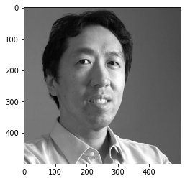 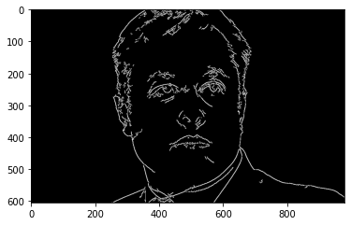

1. **Apply different sigma and different thresholding (high-low) and discuss the results.**

**Sigma = 1.4**

**Sigma = 3**

Applying more Sigma can detect more edges in image with brighter pixel.

**Different Thresholding**

**High : Low:**

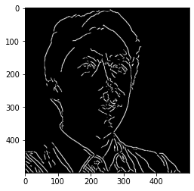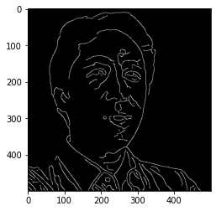

**4.** **If you are using libraries that have canny edge detector compare your implementation of canny with the method and discuss the change.**

import numpy as np

import cv2 as cv

from matplotlib import pyplot as plt

img = cv.imread('Andrew.jpeg',0)

edges = cv.Canny(img,100,200)

plt.subplot(121),plt.imshow(img,cmap = 'gray')

plt.title('Original Image'), plt.xticks([]), plt.yticks([])

plt.subplot(122),plt.imshow(edges,cmap = 'gray')

plt.title('Edge Image'), plt.xticks([]), plt.yticks([])

plt.show()

**Reason:** The edge detection using OpenCV is able to find the minute details based on change in intensity of image. The output edges are more accurate and more precise.